Lesson Plan using Assistive Technology
Unit/Topic: _Reading_ Date:_Apr 2022_

Key Learning Area: Reading Comprehension Year Level:_5 Special Education

Outcomes: After reading a short passage, the student can answer comprehension questions 4/5 times with 90% accuracy

*Note- Student eligible based off basic reading skill and reading comprehension under state requirements

Lesson Outcome
- The student can compare and contrast characters, settings or events
- Student can explain authors point of view
- After reading a short passage, the student can answer comprehension questions 4/5 times with 90% accuracy

LESSON STRUCTURE: online

Online Lesson | Technology used and Research to Support
-Students will utilize school issued laptops with cameras to complete assigned online work  -Students will log into Clever (www.clever.com) using their own specific QR code by holding the QR code up to the camera. This will automatically log the student into their learning platform  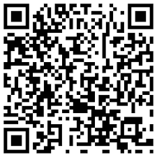 | (QR Code Assistive Technology)  Evidence based practice- www.learntechchlib.org

Online Lesson | Technology Used and Research to Support
- Next the student will click on the icon Education Galaxy, there is a picture on the back of the QR code for reference  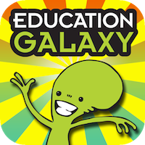 | Picture Assistive Technology so student does not have to read, they can just refer to picture and click  www.educationgalaxy.com
- Once into the platform the student can choose what reading lesson they want to start with. The lesson can be read out loud to the student. The teacher can also adjust the demographics, reading comprehension level as well as speed of the reading to ensure the student can follow along  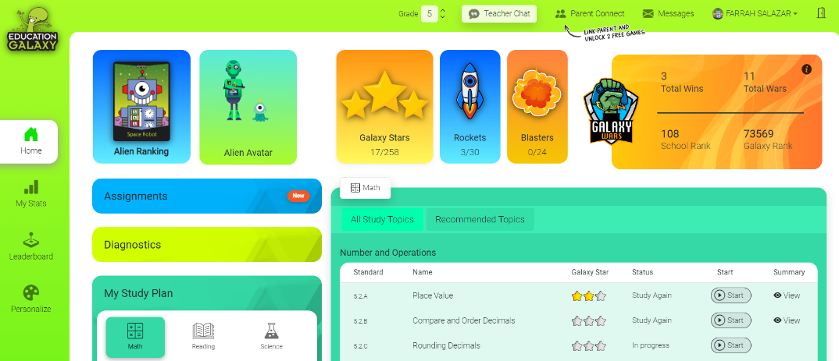  - The teacher will set the timeframe the student must complete the reading task. The platform will show the teacher how much time the student spent on the subject.  - The time the students must complete the reading assignment is 30 minutes. | The Education Galaxy Platform can be adjusted to all students. Reading speeds, background colors and reading levels can all be adjusted to the specific learner.

Resources
(Include equipment required for class and/or for teacher preparation)
- Laptop with camera for every student
- Specific QR code for each student
- Specific page for each student to complete lesson (Every student has their own page on site)

Safety Considerations/Materials
N/A

Assessment
After completion of reading comprehension assignment, students will be able to answer comprehension questions 4/5 times with 90% accuracy. If the assignment is not completed in time or progress shows the student struggled, the teacher will assign more time as well as easier reading assignments to get the student on track with curriculum requirements.

REFLECTION
- This learning platform can be used in all subjects including math, science, and social studies. The teacher can guide and set goals for each student and track their progress. After reading the peer-reviewed and all other articles in this course, I am implementing the best evidence-based practices by making every learning tool easily accessible for all learners, even those with a learning disability. Most of the articles armed a student with a LD with something extra, even if it was just making the screen bigger. In the Education Galaxy platform, not only can font and screen sized be changed, but color and type of context can be changed as well. This site is easily accessible just after a few mouse clicks. Using the QR code instead of a username and password can also assist the students access to the site faster and with ease. Students with a LD can have the story read to them and at their own pace. The platform also tracks their progress and will show the teacher if there are areas needed for improvement or if they are ready to move on to the next level.

